Guide to Intellectual Property: What it is, how to protect it, how to exploit it (Economist Books) (Englisch) Taschenbuch – 14. Juli 2015
https://www.amazon.de/Guide-Intellectual-Property-protect-Economist/dp/1610394615


Images
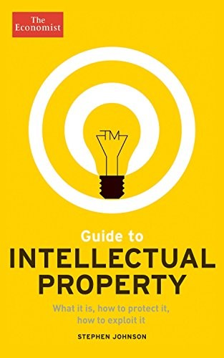

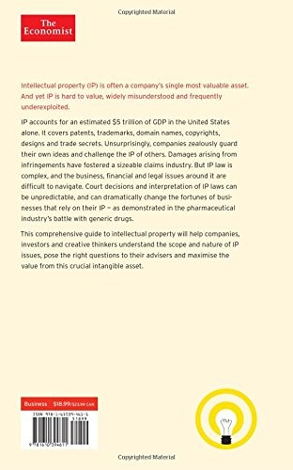

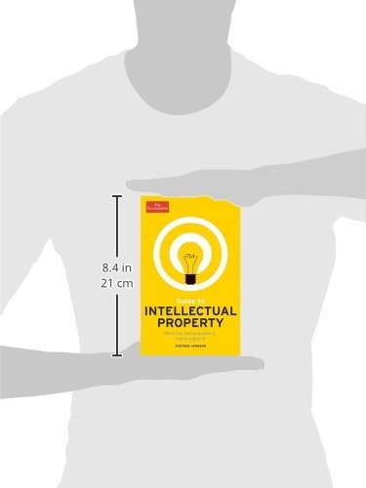

Book Description
Intellectual Property (IP) is often a company's single most valuable asset. And yet IP is hard to value, widely misunderstood and frequently under-exploited.
IP accounts for an estimated 5trn of GDP in the US alone. It covers patents, trademarks, domain names, copyrights, designs and trade secrets. Unsurprisingly, companies zealously guard their own ideas and challenge the IP of others. Damages arising from infringements have fostered a sizeable claims industry. But IP law is complex, and the business, financial and legal issues around it are difficult to navigate. Court decisions and interpretation of IP laws can be unpredictable, and can dramatically change the fortunes of businesses that rely on their IP – as demonstrated in the pharmaceutical industry's battle with generic drugs.
This comprehensive guide to intellectual property will help companies, investors, and creative thinkers understand the scope and nature of IP issues, pose the right questions to their advisers and maximize the value from this crucial intangible asset.

Aus <https://www.amazon.de/Guide-Intellectual-Property-protect-Economist/dp/1610394615>

